**Introduction to Cisco Packet Tracer User Interface**

**Abstract**

This lab report provides an introduction to the Cisco Packet Tracer user interface, a comprehensive network simulation tool widely used for educational purposes. Cisco Packet Tracer enables users to create, configure, and troubleshoot virtual networks, offering a platform to practice and enhance networking skills. The report outlines the key components and functionalities of the user interface, including the workspace, toolbars, device selection area, and simulation panel. Through detailed descriptions and illustrative examples, the report aims to familiarize users with the fundamental operations within Cisco Packet Tracer, facilitating efficient navigation and utilization of its features for network design and analysis. This foundational understanding is crucial for effectively leveraging Cisco Packet Tracer in network configuration and troubleshooting exercises, thereby reinforcing theoretical knowledge with practical application.

**Objective**

The objective of this lab report is to introduce the Cisco Packet Tracer user interface, covering key components such as the workspace, toolbars, device selection area, and simulation panel. By the end of the report, users will be able to navigate the interface, use its features for network design and analysis, and perform network configuration and troubleshooting. This knowledge will help users apply theoretical networking concepts in a simulated environment, enhancing their practical skills and understanding of network operations..

**Introduction**

Cisco Packet Tracer is a network simulation tool by Cisco Systems that enables users to design, configure, and troubleshoot virtual networks. It is widely used in educational settings and by networking professionals to practice and understand networking concepts without physical hardware. This lab report introduces the main components and functionalities of the Packet Tracer user interface, including the workspace, toolbars, device selection area, and simulation panel. By mastering the interface, users can efficiently create network topologies, simulate operations, and apply theoretical networking knowledge in a practical, virtual environment.

**Equipment and Materials**

- A computer with an internet connection.

- Cisco Packet Tracer software installed (version 8.0 or later).

**Methodology**

1. Launching the Application: Begin by opening the Cisco Packet Tracer application on your computer.

2. Familiarizing with the Interface:

- Menu Bar: Found at the top, it offers options for file management, editing, viewing, and accessing various tools.

- Common Tools Bar: Provides quick access to commonly used tools like selection, zoom, and inspect.

- Network Component Box: Categorized into sections such as Routers, Switches, and End Devices, allowing users to drag and drop devices into the workspace.

- Workspace: The central area for constructing and visualizing network topologies. Users can toggle between Logical and Physical Workspace Tabs for different views.

- Toolbar: Located at the bottom, it includes tools for controlling simulations, including real-time and simulation modes, as well as play, pause, and reset buttons.

3. Creating a Basic Network:

- Drag and drop devices like a router, a switch, and multiple PCs into the workspace.

- Use appropriate cables to connect these devices, ensuring proper connectivity.

4. Simulating Network Traffic:

- Switch to simulation mode to simulate network traffic.

- Generate and observe data packets to understand traffic flow and identify potential issues within the network.

**Result**

After completing these steps, users will be able to:

- Recognize and navigate the different components of the Cisco Packet Tracer interface.

- Construct a basic network topology using various networking devices.

- Configure network devices with appropriate settings.

- Simulate network traffic and analyze data packet flow to diagnose and resolve issues.

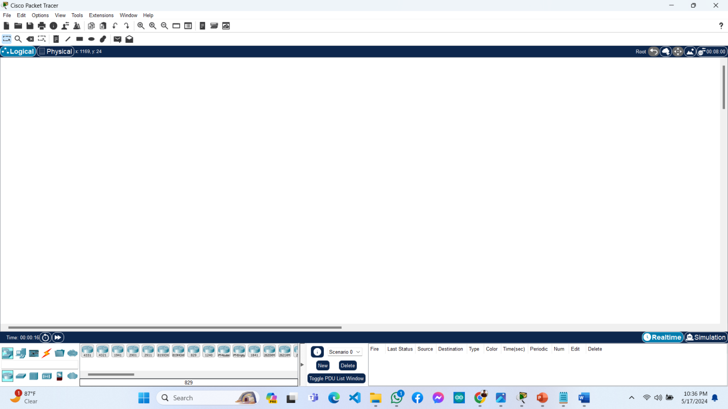

**Discussion**

Comprehending the Cisco Packet Tracer interface is crucial for individuals embarking on their networking education journey. Its user-friendly layout facilitates swift network setup and simulation, rendering it an invaluable educational asset. Navigating through its various sections enables users to adeptly handle network components and configurations, thereby enriching their educational journey in networking.

**Conclusion**

This lab provided an overview of the Cisco Packet Tracer user interface, emphasizing its essential components and capabilities. Acquiring familiarity with the interface empowers users to proficiently generate and simulate diverse network scenarios, a fundamental aspect of networking education.

**Connecting different Computers to Home Router**

## Abstract

## In this lab report, the procedure of linking various computers to a home router using Cisco Packet Tracer is investigated. Through the setup of a rudimentary home network simulation, the report delineates the necessary steps for router configuration and the establishment of effective communication among computers.

## Objective

## The objective of this lab is to grasp the process of connecting multiple computers to a home router in Cisco Packet Tracer and to acquire skills in configuring the router to facilitate communication among the connected devices.

## Introduction

In contemporary households, it's typical to link numerous devices to the internet via a single router, and Cisco Packet Tracer serves as a valuable tool for designing and comprehending network setups. This lab specifically simulates a straightforward home network configuration, where various computers connect to a router and are configured to enable intercommunication.

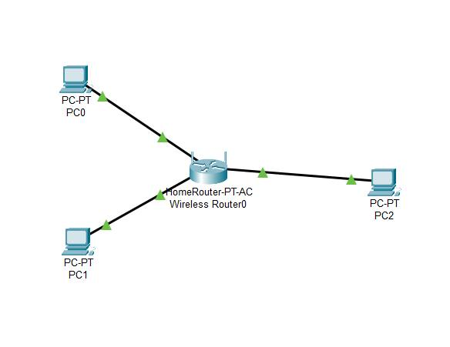

**Equipment and Materials**

* Cisco Packet Tracer software
* Virtual devices within Cisco Packet Tracer:
  + 1 Home Router
  + 3 Computers (PC-0, PC-1, PC-2)
  + Ethernet cables

**Methodology**

1. **Setup the Network Layout:**
   * Open Cisco Packet Tracer.
   * Drag and drop a home router and three computers (PC-0, PC-1, PC-2) onto the workspace.
   * Connect each computer to the router using Ethernet cables.
2. **Configure the Router:**
   * Click on the router to open its configuration menu.
   * Assign IP addresses to each port connected to the computers. For example:
     + Router Interface (connected to PC-0): 192.168.1.0
     + Router Interface (connected to PC-1): 192.168.1.1
     + Router Interface (connected to PC-2): 192.168.1.2
3. **Configure the Computers:**
   * Click on each computer to open its configuration menu.
   * Assign an IP address and subnet mask to each computer. For example:
     + PC-1: IP address 192.168.1.0, Subnet Mask 255.255.255.0
     + PC-2: IP address 192.168.1.1, Subnet Mask 255.255.255.0
     + PC-3: IP address 192.168.1.2, Subnet Mask 255.255.255.0
4. **Testing Connectivity:**
   * Use the Command Prompt in each computer to ping the other computers and the router to ensure they are properly connected.
   * For instance, on PC-1, type ping 192.168.1.2 to check connectivity to PC-2.

**Result**

Following the configuration of the router and computers, successful communication was established among all devices, as confirmed by the ping tests conducted between the computers and the router, validating the correctness of the network setup.

**Discussion**

This lab illustrates the foundational steps of creating a home network with Cisco Packet Tracer, where configuring IP addresses and subnet masks facilitates communication among computers via the router, laying the groundwork for tackling intricate network setups and diagnosing connectivity problems.

**Conclusion**

Connecting various computers to a home router using Cisco Packet Tracer is a streamlined process that entails network layout setup, IP address configuration, and connectivity verification. This lab effectively showcased the essential procedures for establishing a basic home network, fostering comprehension of network setup and configuration fundamentals.

**Packet Transfer Between Connected Computers**

**Abstract**

This lab report investigates packet transfer between computers using Cisco Packet Tracer, analyzing the journey of data packets across a basic network setup to gain insights into networking fundamentals and the simulation capabilities of Cisco Packet Tracer as a learning tool.

**Objective**

The objective of this lab is to showcase the transfer of data packets between computers in a network using Cisco Packet Tracer, involving the establishment of a basic network setup, packet transmission, and observation of the transfer process for enhanced understanding.

**Introduction**

Packet transfer, a cornerstone of networking, involves breaking data into smaller units known as packets for transmission; Cisco Packet Tracer facilitates the creation of network topologies and simulates this data transfer process, aiding in diagnosing network issues and optimizing performance.

**Equipment and Materials**

* Computer with Cisco Packet Tracer installed
* Cisco Packet Tracer software

**Methodology**

1. **Network Setup**:
   * Open Cisco Packet Tracer and create a new project.
   * Add two computers (PC1 and PC2) to the workspace.
   * Add a switch to the workspace.
   * Connect PC1 and PC2 to the switch using copper straight-through cables.
2. **Configuration**:
   * Assign IP addresses to the computers:
     + PC0: IP address 192.168.1.1, Subnet mask 255.255.255.0
     + PC1: IP address 192.168.1.2, Subnet mask 255.255.255.0
   * Ensure the switch is powered on and properly connected.
3. **Packet Transfer**:
   * Use the "Simple PDU" tool in Cisco Packet Tracer to create a packet from PC1 to PC2.
   * Observe the packet transfer process by following the simulation.

**Result**

Upon network setup and packet transfer initiation, successful transmission is observed as the packet traverses from PC1 to PC2 via the switch, affirming the accuracy of the network configuration.

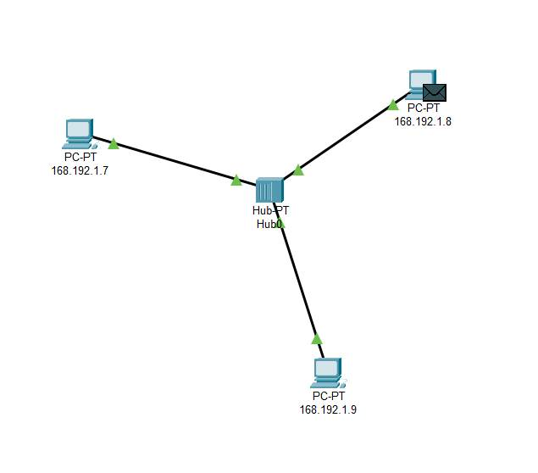

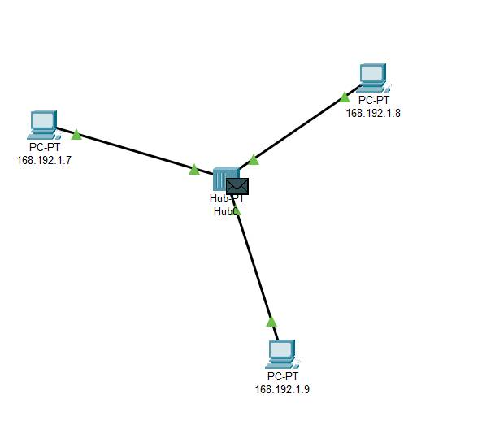

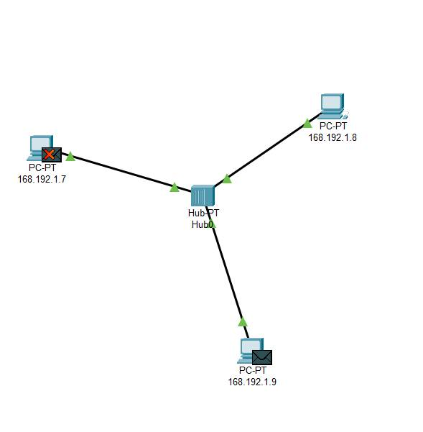

**Discussion**

The confirmed packet transfer from PC0 to PC1 validates the network's operational status, with the simulation illustrating encapsulation, preparing data for transmission, and decapsulation, receiving and unpacking data, highlighting Cisco Packet Tracer's role in visualizing and comprehending packet transfer steps for effective troubleshooting and real-world network optimization.

**Conclusion**

Effectively showcasing packet transfer between computers, this lab utilized Cisco Packet Tracer to establish a basic network, providing insights into data transmission within networks, highlighting the tool's significance for simulating and comprehending networking principles.

**Setting up a Network using Hub**

**Abstract**

This report delineates the process of configuring a basic network with a hub in Cisco Packet Tracer, involving the connection of numerous devices to facilitate communication, showcasing the fundamental operations of a hub in network setups, and exploring the implications and limitations relative to switches.

**Objective**

The objective of this lab is to establish a rudimentary network employing a hub in Cisco Packet Tracer, examining data transmission within the network, and comprehending the core disparities between hubs and switches.

**Introduction**

In networking, hubs serve as elementary devices linking multiple computers in a local area network (LAN), contrasting with switches as they broadcast data to all network devices, potentially resulting in data collisions and inefficiencies; this lab offers a practical exploration of hub functionality and its significance in networking.

**Equipment and Materials**

* Cisco Packet Tracer software
* Personal computer with Cisco Packet Tracer installed
* Network devices within Cisco Packet Tracer (hub, PCs, and cables)

**Methodology**

1. **Start Cisco Packet Tracer:** Open the Cisco Packet Tracer software on your computer.
2. **Add Devices:** From the device list, drag and drop the following onto the workspace:
   * One hub
   * Four PCs (PC0, PC1, PC2, PC3)
3. **Connect Devices:** Use copper straight-through cables to connect each PC to the hub. To do this:
   * Click on PC0, select "Copper Straight-Through," and connect it to the hub.
   * Repeat the process for PC1, PC2, and PC3.
4. **Assign IP Addresses:** Click on each PC, go to the Desktop tab, open IP Configuration, and assign the following IP addresses:
   * PC0: 192.168.1.1
   * PC1: 192.168.1.2
   * PC2: 192.168.1.3
   * PC3: 192.168.1.4
5. **Test Connectivity:** Use the Command Prompt in each PC to ping the other PCs to test network connectivity.

**Results**

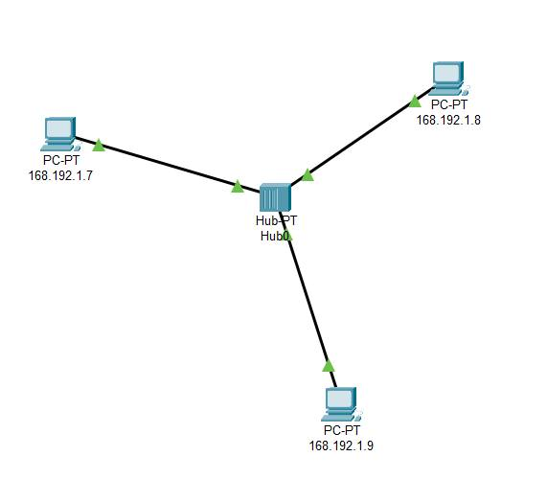

Successful connection of all PCs to the hub enabled mutual pinging between each PC, affirming data transmission across the network and validating the hub's proper functionality in facilitating communication among connected devices.

**Discussion**

The experiment showcased how hubs facilitate communication among multiple devices in a network; however, their tendency to broadcast data to all connected devices can result in data collisions and decreased efficiency, unlike switches which direct data to specific devices, mitigating collisions and enhancing performance, emphasizing the foundational role of hubs and paving the way for advanced network device comprehension.

**Conclusion**

Configuring a network with a hub in Cisco Packet Tracer elucidated the fundamental functions of hubs in network operations, underscoring their suitability for smaller networks but also highlighting drawbacks such as data collisions and inefficiencies relative to switches, thereby underscoring the significance of comprehending various network devices for effective network design.

### **Setting Up a Network Using a Switch**

#### **Abstract**

#### This lab report illustrates the configuration of a simple network with a switch in Cisco Packet Tracer, encompassing device connection, IP address configuration, and connectivity verification, with a focus on grasping the foundational procedures of network establishment and device interaction facilitated by a switch.

#### **Objective**

The objective of this lab is to:

1. Learn how to use Cisco Packet Tracer for network simulation.
2. Understand the process of setting up a network with a switch.
3. Configure and assign IP addresses to devices.
4. Verify network connectivity between devices.

#### **Introduction**

#### Networking facilitates resource sharing and efficient communication among multiple devices, with Cisco Packet Tracer serving as a simulation tool for practicing network configuration and troubleshooting; this lab entails configuring a straightforward network with a switch and linking PCs and servers to showcase fundamental networking concepts.

#### **Equipment and Materials**

* Cisco Packet Tracer software
* A computer with Cisco Packet Tracer installed
* Basic understanding of networking concepts

#### **Methodology**

1. **Start Cisco Packet Tracer**: Open the software on your computer.
2. **Add Devices**: Drag and drop a switch and several PCs from the device menu to the workspace.
3. **Connect Devices**: Use the "Copper Straight-Through" cable to connect each PC to the switch.
4. **Assign IP Addresses**: Click on each PC, go to the Desktop tab, and then IP Configuration. Assign IP addresses within the same subnet (e.g., 192.168.1.1, 192.168.1.2, etc.).
5. **Configure the Switch (Optional)**: Typically, basic switch configuration is not required for simple setups, but you can assign a management IP if needed.
6. **Verify Connectivity**: Use the "Ping" command from the command prompt on each PC to test connectivity between devices.

#### **Result**

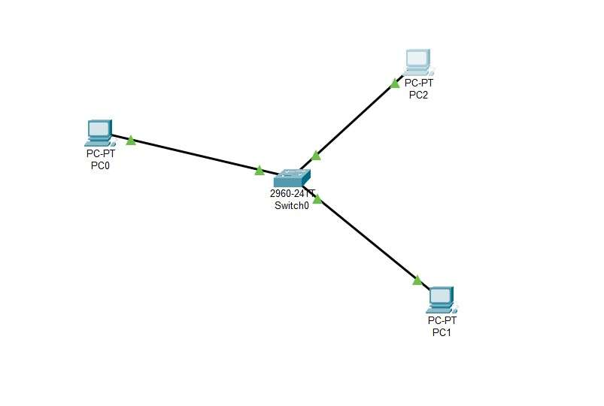

#### Following setup completion, every PC should achieve communication with others in the network, with successful "Ping" command responses confirming the network's accurate configuration.

#### **Discussion**

#### This lab effectively demonstrated the ease of configuring a network with a switch in Cisco Packet Tracer, showcasing effective device communication by assigning IP addresses within the same subnet and establishing proper cabling, with the switch serving as a central hub facilitating seamless data transfer among connected devices.

#### **Conclusion**

#### Configuring a network with a switch in Cisco Packet Tracer serves as a fundamental exercise in grasping network fundamentals, emphasizing the significance of accurate IP configuration and highlighting the pivotal role of switches in network infrastructure, with successful ping tests validating network connectivity.

**Setting up and Connecting Different Networks Using Router**

**Abstract**

The lab experiment focused on configuring and interconnecting networks using routers in Cisco Packet Tracer, aiming to comprehend router configuration and functionality in enabling communication across multiple networks; practical implementation and simulation were employed to create and analyze diverse network topologies, ultimately achieving desired connectivity.

**Objective**

The objective of this lab is to acquire hands-on experience in configuring and linking diverse networks using routers in Cisco Packet Tracer, aiming to grasp routing principles and the role of routers in facilitating communication among distinct networks through the configuration of routers and the creation of diverse network topologies.

**Introduction**

Routers are pivotal in computer networking, directing traffic between diverse networks by forwarding data packets based on network addresses; leveraging Cisco Packet Tracer, this lab experiment centers on configuring and linking various networks using routers, facilitating network modeling and configuration learning.

**Equipment and Materials**

1. Cisco Packet Tracer software
2. Computers or laptops
3. Routers
4. Ethernet cables
5. Switches (optional, depending on network topology)

**Methodology**

1. **Network Design:** Plan the network topology to be implemented, including the number of networks, IP addressing scheme, and router placement.
2. **Router Configuration:** Configure each router with appropriate IP addresses for their interfaces and enable routing protocols such as RIP, OSPF, or EIGRP.
3. **Interconnection:** Physically connect routers to each other using Ethernet cables, ensuring proper interface assignment.
4. **Testing Connectivity:** Verify connectivity between devices within the same network and across different networks using tools like ping and traceroute.
5. **Troubleshooting:** Identify and troubleshoot any connectivity issues that arise, adjusting configurations as needed.
6. **Documentation:** Document the configurations made, network topology, and any observations or challenges encountered during the setup process.

**Results**

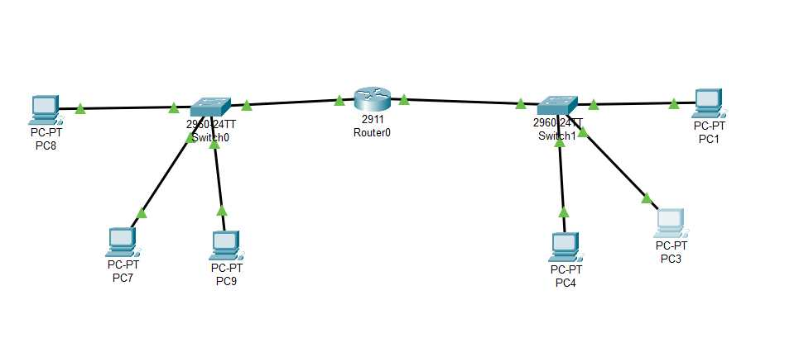

* Successful establishment of connectivity between multiple networks.
* Verification of routing functionality through ping and traceroute commands.
* Identification and resolution of any connectivity issues encountered during configuration.

**Discussion**

Through router configuration and network interconnection in Cisco Packet Tracer, the lab experiment elucidated networking basics, routing protocols, IP addressing, and troubleshooting methods, offering hands-on exposure to router-mediated communication across distinct networks in real-world scenarios.

**Conclusion**

This lab experiment equipped participants with practical skills in configuring and linking diverse networks using routers in Cisco Packet Tracer, bolstering comprehension of routing principles, IP addressing, and network connectivity, crucial for individuals advancing in networking careers or aiming to enhance proficiency in network configuration and management.